**How to connect a Citizen WiFi (Fulfillment Ticket Printer)**

**Step One:** Turn on the Citizen Wifi Printer; press and hold the Power and Feed button until you hear a beep.

**Step Two:** Wait 10 seconds and then press the black button on the back bottom right of the printer.

**Step Three:** After you hear a second beep simply press and release the button at the back of the printer and a ticket will print with an IP address with (DCHP) at the end of the IP Address

**Step Four:** Open a new window at your desktop or laptop computer that shares the same internet source and enter the IP Address in the address bar and press enter. This will bring you to the page in the image below: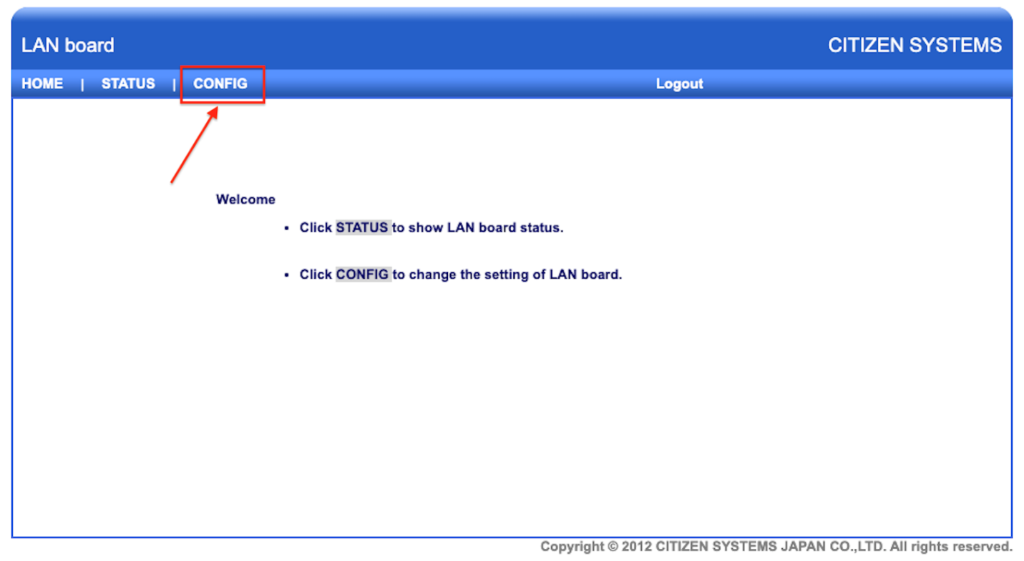

**Step Five:** Press on the CONFIG option in the screen above.  This will require you to log into the LAN board.  The username is admin and the password is also admin. After entering the username and password into the fields provided press the Login CTA Button.  See the image below.

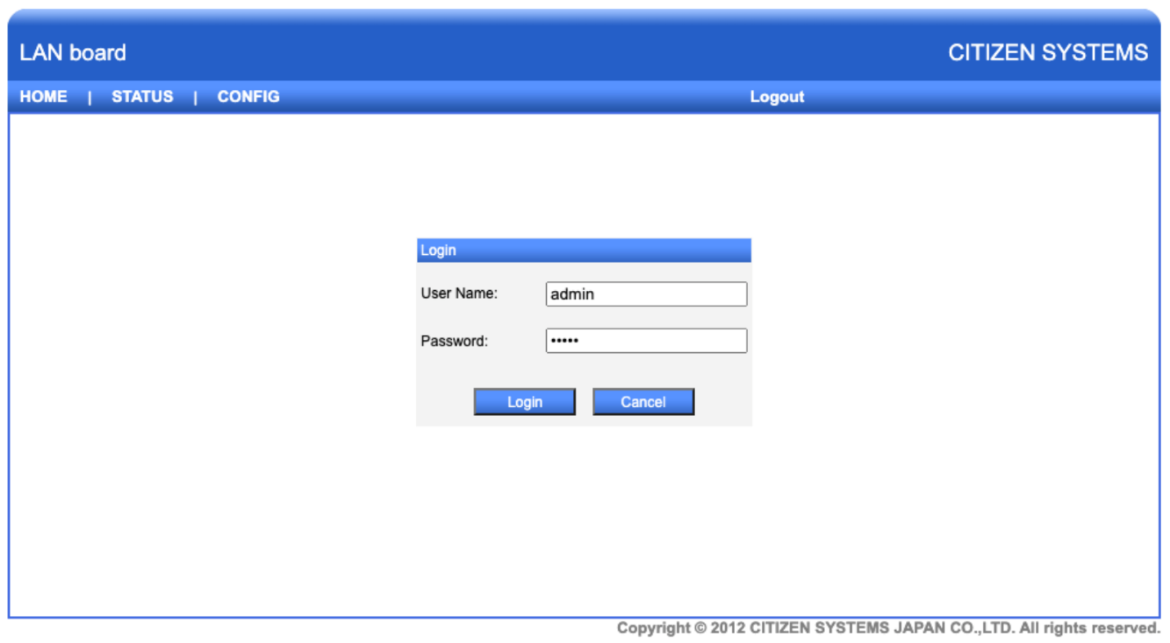

**Step Six:** You will need to enter the following URL <https://admin.teesnap.com/teesnap-rest-service/print-jobs-citizen> at the Request Print tab

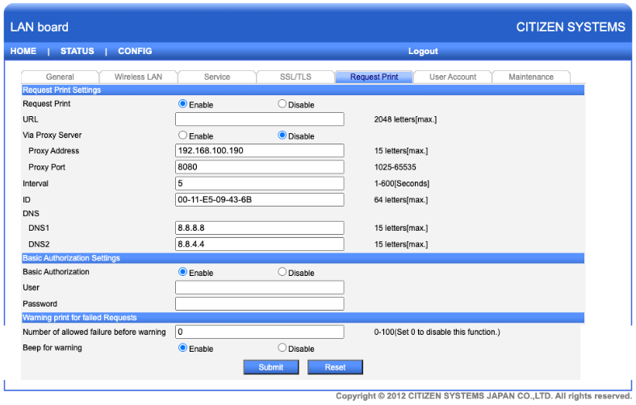

You will also want to make the interval 5 (seconds) on this tab.  At this time you will need to log into the admin portal and configure a Printer to then be able to enter the User and Password from Teesnap.

**Step**

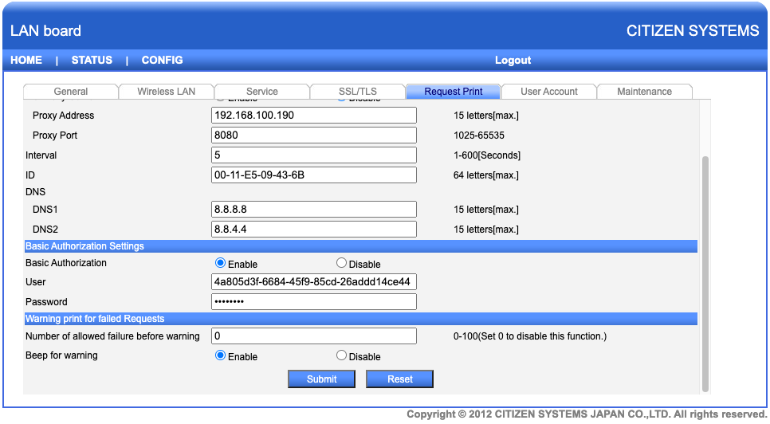

After they hit submit they will press on the Maintenance Tab so they can Save and Reboot.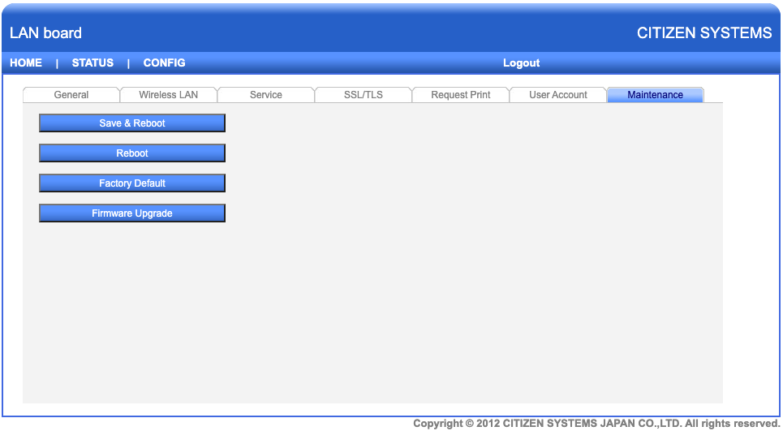

Next they will press the Yes CTA button to begin the save and reboot process.

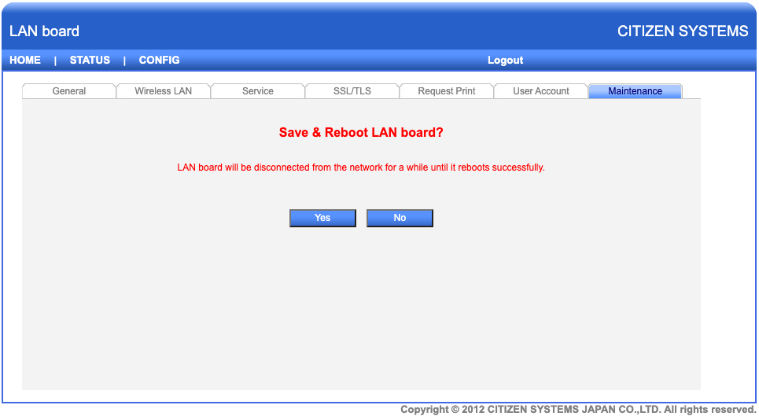

You will see the messaging below while it reboots.

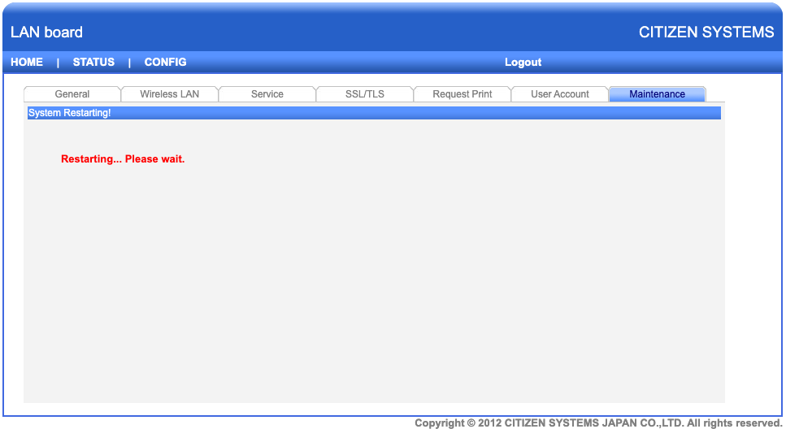

Upon the completion it will take you back to the Citizen Landing Page.  At this point return to the Admin Portal and press the printer ICON to perform a test print.  If successful you are all set.